Important Note: Write access is often exclusive, in order to gain write access in instances in which multi-writer privs are blocked remove the Direct Statements referencing those MDISKs.  
Syntax:

• Purple segments are COMMANDS.

• Red segments are user/circumstance/device supplied values.

• Blue segments are options and operands of the command.

~~~~~~~~~~~~~~~~~~~~~~~~~~~~~~~~~~~~~~~~~ Method 1~~~~~~~~~~~~~~~~~~~~~~~~~~~~~~~~~~~~~~~~~~~~~~~~~

1. Form a **Link** to be used to access the MDISK
   1. Link userid vdev1 vdev2 Accessmode  
       (original dev name) (name to access)
      1. Ex. Link vm00ja 191 5191 WR  
          
2. Utilize the formed Link by Accessing it
   1. Access vdev2 filemode  
       (ex. 191 is A)
      1. Ex. Access 5191 w  
            
          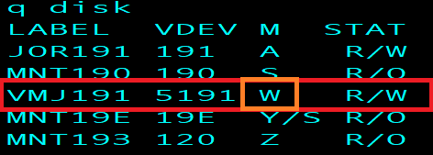
3. It should now be possible to manipulate the contents of your Linked and Accessed device
4. Release the device(s) once you have finished work
   1. Release mode
      1. Ex. Rel w  
            
          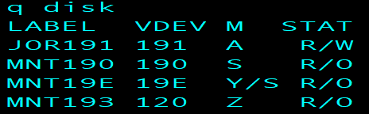
5. Remember to restore the removed link if you modified a Direct file to gain Write access

~~~~~~~~~~~~~~~~~~~~~~~~~~~~~~~~~~~~~~~~~~ Method 2~~~~~~~~~~~~~~~~~~~~~~~~~~~~~~~~~~~~~~~~~~~~~~~~

1. Add write access to a VMLink
   1. VMLINK user mdiskvdev (write  
      vmlink janders 191 (write  
      
2. Don’t forget that it’s possible to damage other user’s files this way. Make copies and edit those if you intend to make file changes.